DBMS STRUCTURE ENQUIRY

Prof. Savita Bakare

TEAM-08

|  |  |  |
| --- | --- | --- |
| ROLL NO | NAME | SRN |
| 19 | PARASNATH DODDANNAVAR | 02FE22BCS063 |
| 20 | PRAJWAL KESARGOPPA | 02FE22BCS066 |
| 21 | PRASHANT UPPAR | 02FE22BCS069 |

REPORT OWNER

|  |  |  |
| --- | --- | --- |
| ROLL NO | NAME | SRN |
| 21 | PRASHANT UPPAR | 02FE22BCS069 |

PROBLEM STATEMENT:

Online Restaurant Menu Ordering System (Odd Group Number)

Online Restaurant Menu Ordering System facilitates the food items ordering and services within a restaurant. The customer is able to view the food items menu, call the waiter, place orders and obtain the final bill through the computer kept in their table. The waiters through their wireless tablet PC are able to initialize a table for customers, control the table functions to assist customers, orders, send orders to food preparation staff (chef) and finalize the customer's bill. The food preparation staffs (chefs), with their touch-display interfaces to the system, are able to view orders sent to the kitchen by waiters. During preparation, they are able to let the waiter know the status of each item, and can send notifications when items are completed. The system should have full accountability and logging facilities, and should support supervisor actions to account for exceptional circumstances, such as a meal being refunded or walked out on.

ER – MODEL:

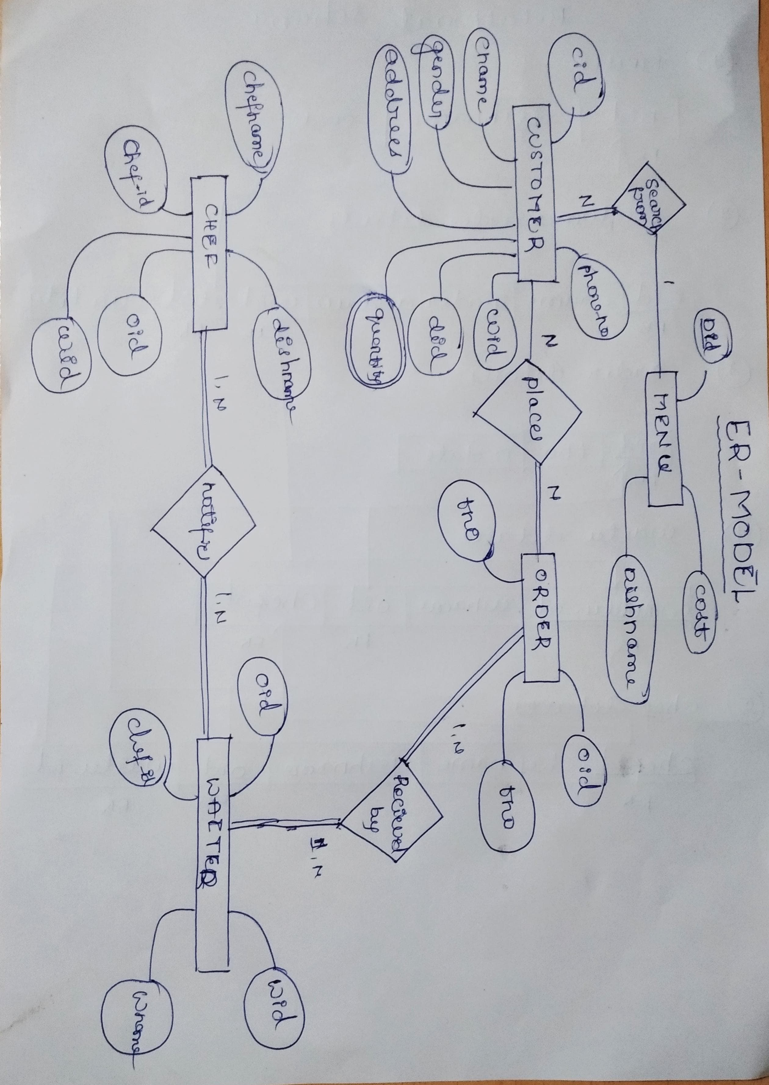

Relational SCHEMA:

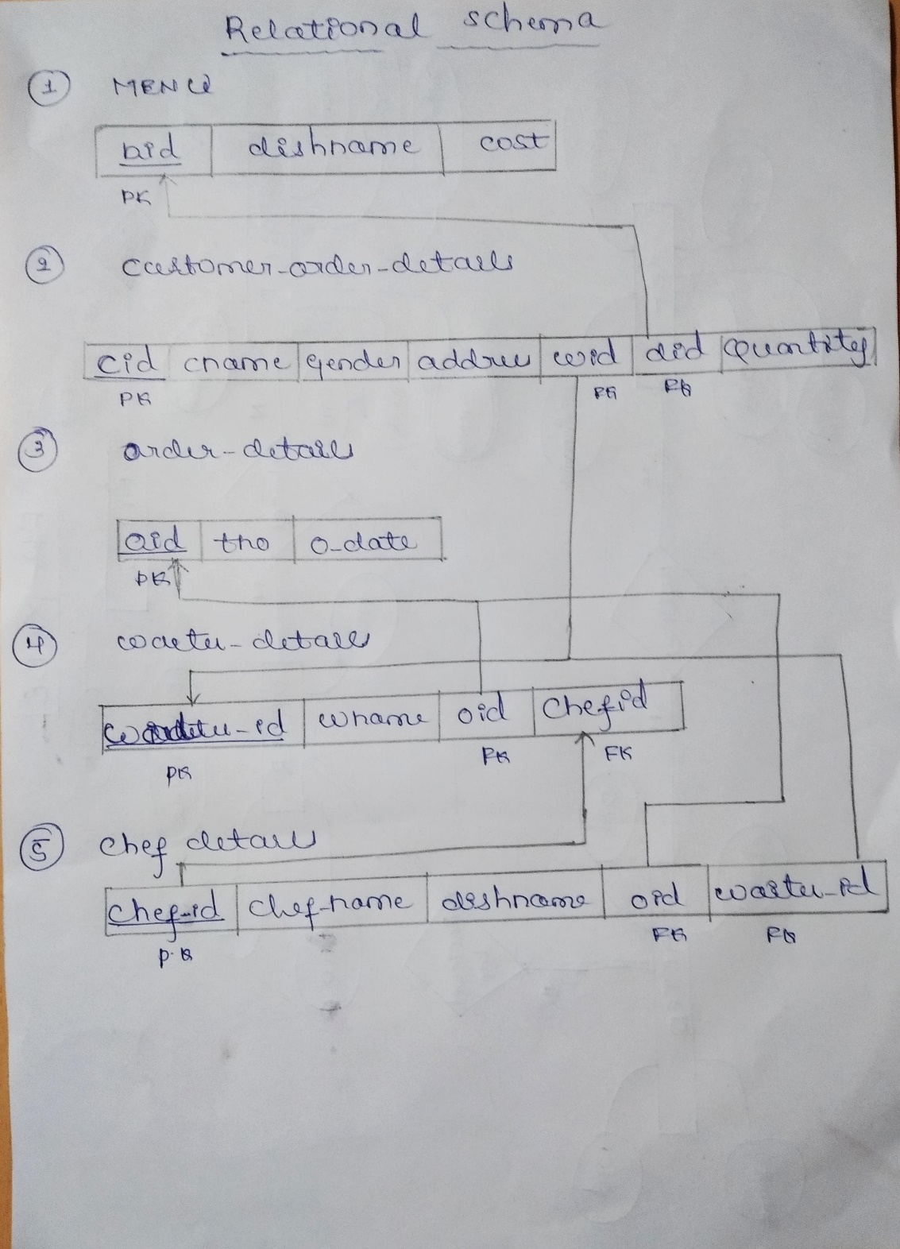

NORMALITION:

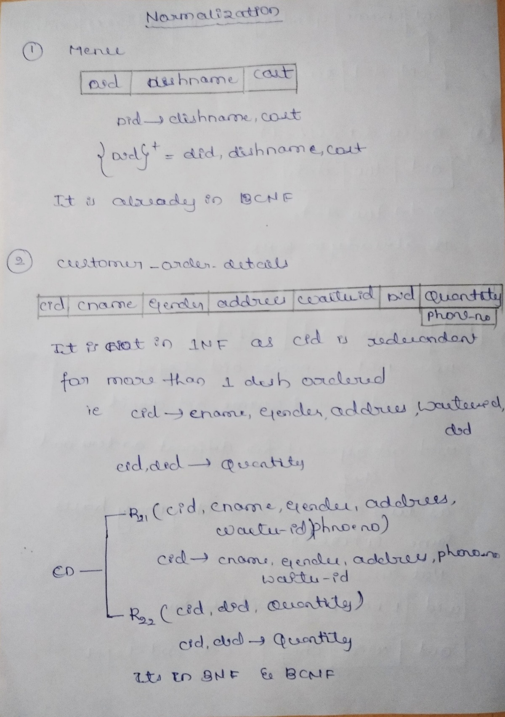

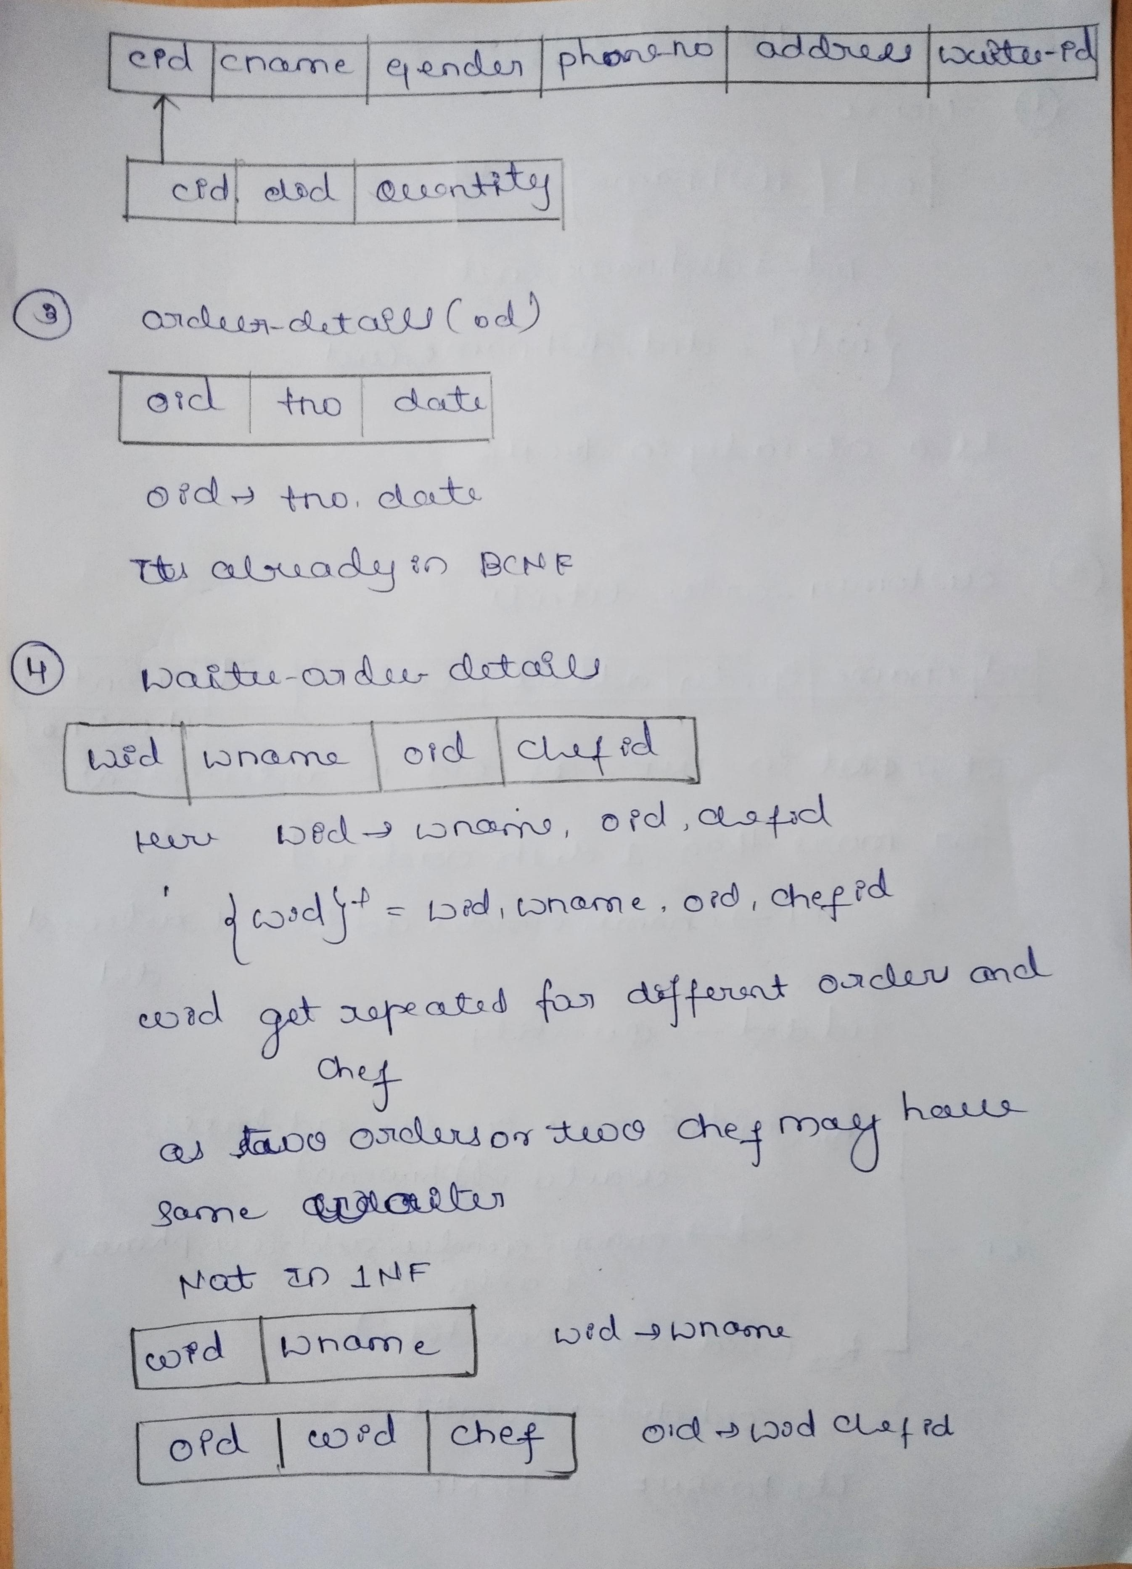

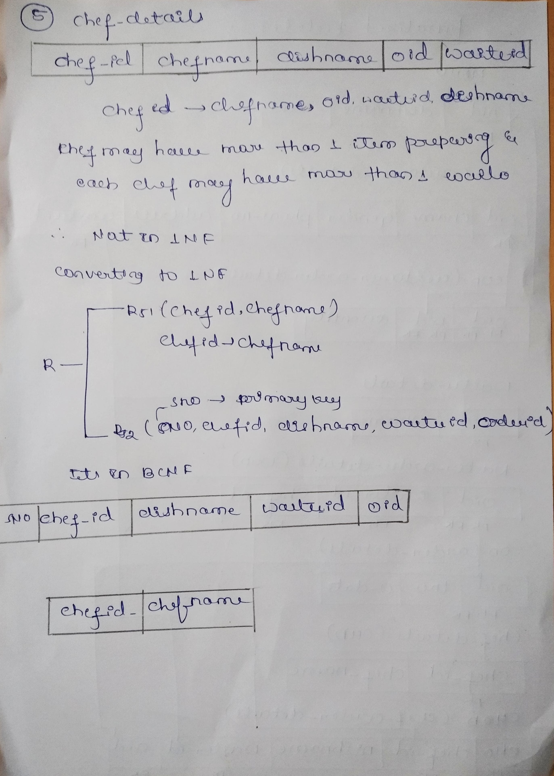

Finalized tables:

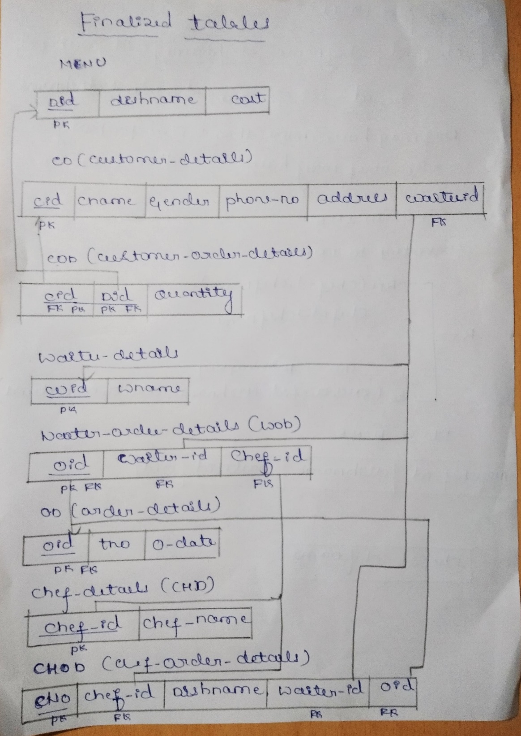

Table creation:

CREATE TABLE MENU

( DID INT,

DISHNAME VARCHAR2(50),

COST FLOAT,

PRIMARY KEY(DID));

CREATE TABLE CD

( CID NUMBER(4),

CNAME VARCHAR2(50),

GENDER VARCHAR2(1),

PHONE_NO NUMBER(10),

ADDRESS VARCHAR2(50),

WAITER_ID NUMBER(3),

PRIMARY KEY(CID));

CREATE TABLE COD

( CID NUMBER(4),

DID INT,

QUANTITY INT,

PRIMARY KEY(CID,DID));

CREATE TABLE WAITER_DETAILS

( WID NUMBER(3),

WNAME VARCHAR2(50),

PRIMARY KEY(WID)

);

CREATE TABLE OD

( OID NUMBER(2),

TNO NUMBER NUMBER(2),

O_DATE DATE,

PRIMARY KEY(OID));

CREATE TABLE WOD

( OID NUMBER(2) ,

CHEF_ID NUMBER(1),

WAITER_ID NUMBER(3),

PRIMARY KEY(OID));

CREATE TABLE CHD

( CHEF_ID NUMBER(1),

CHEF_NAME VARCHAR2(50),

PRIMARY KEY(CHEF_ID));

CREATE TABLE CHOD

( SNO INT,

CHEF_ID NUMBER(1),

DISHNAME VARCHAR2(50),

WAITER_ID NUMBER(3),

OID NUMBER(2),

PRIMARY KEY(SNO));

Table description:

SQL> desc menu;

Name Null? Type

----------------------------------------- -------- ----------------------------

DID NOT NULL NUMBER(38)

DISHNAME VARCHAR2(50)

COST FLOAT(126)

SQL> desc cd;

Name Null? Type

----------------------------------------- -------- ----------------------------

CID NOT NULL NUMBER(4)

CNAME VARCHAR2(50)

GENDER VARCHAR2(1)

PHONE_NO NUMBER(10)

ADDRESS VARCHAR2(50)

WAITER_ID NUMBER(3)

SQL> desc cod;

Name Null? Type

----------------------------------------- -------- ----------------------------

CID NOT NULL NUMBER(4)

DID NOT NULL NUMBER(38)

QUANTITY NUMBER(38)

SQL> desc waiter_details;

Name Null? Type

----------------------------------------- -------- ----------------------------

WID NOT NULL NUMBER(3)

WNAME VARCHAR2(50)

SQL> desc wod;

Name Null? Type

----------------------------------------- -------- ----------------------------

OID NOT NULL NUMBER(2)

WAITER_ID NUMBER(3)

CHEF_ID NUMBER(1)

SQL> desc chd;

Name Null? Type

----------------------------------------- -------- ----------------------------

CHEF_ID NOT NULL NUMBER(1)

CHEF_NAME VARCHAR2(50)

SQL> desc chod;

Name Null? Type

----------------------------------------- -------- ----------------------------

SNO NOT NULL NUMBER(38)

CHEF_ID NUMBER(1)

DISHNAME VARCHAR2(50)

WAITER_ID NUMBER(3)

OID NUMBER(2)

SQL> DESC OD;

Name Null? Type

----------------------------------------- -------- ----------------------------

OID NOT NULL NUMBER(2)

TNO NUMBER(2)

O_DATE DATE

TABLE DATA:

SQL> select *from menu;

DID DISHNAME COST

---------- -------------------------------------------------- ----------

1 CHICKEN BIRYANI 210

2 MUTTON BIRYANI 253

3 CHICKEN FAMILY PACK 552

4 MUTTON FAMILY PACK 576

5 SPECIAL CHICKEN BIRYANI 337

6 SPECIAL MUTTON BIRYANI 351

7 SUPREME CHICKEN BIRYANI 784

8 SUPREME MUTTON BIRYANI 819

9 EGG BIRYANI 154

10 VEG BIRYANI 154

11 MUTTON THALI 355

DID DISHNAME COST

---------- -------------------------------------------------- ----------

12 CHICKEN THALI 283

13 VEG TAHLI 212

14 VEG FAMILY PACK 383

15 VEG SUPREME PACK 574

16 CHILLY CHICKEN 264

17 CHICKEN 65 264

18 PEPPER CHICKEN 264

19 PANNER 65 196

20 VEG MANCHURIAN 189

21 CHICKEN TIKKA KEBAB 243

22 TANDOORI CHICKEN(HALF) 243

DID DISHNAME COST

---------- -------------------------------------------------- ----------

23 TANDOORI CHICKEN(FULL) 379

24 CHICKEN RESHMI KEBAB 243

25 CHICKEN GARLIC KEBAB 243

26 BUTTER CHICKEN BONELESS 246

27 NIZAMI HANDI 171

28 TANDOORI ROTI 40

29 RUMALI ROTI 40

30 WATER BOTTLE 20

30 rows selected.

SQL> select *from cd;

CID CNAME G PHONE_NO

---------- -------------------------------------------------- - ----------

ADDRESS WAITER_ID

-------------------------------------------------- ----------

1 Amit M 9876543210

Delhi 1

2 Pooja F 8765432109

Mumbai 4

3 Rahul M 7654321098

Kolkata 1

CID CNAME G PHONE_NO

---------- -------------------------------------------------- - ----------

ADDRESS WAITER_ID

-------------------------------------------------- ----------

4 Neha F 6543210987

Chennai 4

5 Sandeep M 5432109876

Bangalore 3

6 Deepika F 4321098765

Hyderabad 2

CID CNAME G PHONE_NO

---------- -------------------------------------------------- - ----------

ADDRESS WAITER_ID

-------------------------------------------------- ----------

7 Vikram M 3210987654

Pune 3

8 Sunita F 2109876543

Jaipur 3

9 Raj M 1098765432

Ahmedabad 4

CID CNAME G PHONE_NO

---------- -------------------------------------------------- - ----------

ADDRESS WAITER_ID

-------------------------------------------------- ----------

10 Anita F 9876543210

Lucknow 5

11 Vishal M 8765432109

Chandigarh 3

12 Priya F 7654321098

Indore 4

CID CNAME G PHONE_NO

---------- -------------------------------------------------- - ----------

ADDRESS WAITER_ID

-------------------------------------------------- ----------

13 Amitabh M 6543210987

Bhopal 3

14 Deepa F 5432109876

Nagpur 1

15 Rajesh M 4321098765

Surat 4

CID CNAME G PHONE_NO

---------- -------------------------------------------------- - ----------

ADDRESS WAITER_ID

-------------------------------------------------- ----------

16 Sushma F 3210987654

Kanpur 5

17 Arun M 2109876543

Bhubaneswar 3

18 Anjali F 1098765432

Noida 1

CID CNAME G PHONE_NO

---------- -------------------------------------------------- - ----------

ADDRESS WAITER_ID

-------------------------------------------------- ----------

19 Prateek M 9876543210

Gurgaon 4

20 Shilpa F 8765432109

Faridabad 4

20 rows selected.

SQL> select *from cod;

CID DID QUANTITY

---------- ---------- ----------

1 1 2

1 17 2

1 10 1

1 30 3

2 23 3

2 21 4

2 28 8

2 26 2

3 19 2

3 13 4

4 12 4

CID DID QUANTITY

---------- ---------- ----------

4 29 10

5 11 4

5 18 3

6 20 8

6 5 2

7 14 2

7 15 1

8 16 4

8 18 2

9 9 5

9 8 3

CID DID QUANTITY

---------- ---------- ----------

10 7 4

10 6 5

11 4 2

11 1 4

12 6 7

12 8 3

13 10 6

13 13 4

14 14 3

14 17 8

15 19 1

CID DID QUANTITY

---------- ---------- ----------

15 20 3

16 23 7

16 24 6

17 25 8

17 26 3

18 30 6

18 23 2

19 18 3

19 17 5

20 30 8

20 5 3

44 rows selected.

SQL> select *from waiter_details;

WID WNAME

---------- --------------------------------------------------

1 Ravi

2 Amit

3 Sneha

4 Ananya

5 Prakash

SQL> select *from od;

OID TNO O_DATE

---------- ---------- ---------

1 3 29-DEC-23

2 3 25-DEC-23

3 10 01-JAN-24

4 5 04-DEC-23

5 3 12-DEC-23

6 2 08-JAN-24

7 8 26-DEC-23

8 2 23-DEC-23

9 8 05-DEC-23

10 8 31-DEC-23

11 2 30-JAN-24

OID TNO O_DATE

---------- ---------- ---------

12 3 28-DEC-23

13 1 23-JAN-24

14 7 22-DEC-23

15 7 31-DEC-23

16 4 02-JAN-24

17 5 05-JAN-24

18 3 05-DEC-23

19 4 28-DEC-23

20 8 16-JAN-24

20 rows selected.

SQL> select *from wod;

OID WAITER_ID CHEF_ID

---------- ---------- ----------

1 1 3

2 4 2

3 1 1

4 4 4

5 3 2

6 2 5

7 3 1

8 3 2

9 4 4

10 5 5

11 3 2

OID WAITER_ID CHEF_ID

---------- ---------- ----------

12 4 1

13 3 4

14 1 2

15 4 3

16 5 4

17 3 2

18 1 1

19 4 5

20 4 1

20 rows selected.

SQL> select *from chd;

CHEF_ID CHEF_NAME

---------- --------------------------------------------------

1 Aarav

2 Aditi

3 Aryan

4 Ishaan

5 Kavya

6 Aradhya

7 Aryan

8 Mehak

9 Arjun

9 rows selected.

SQL> select *from chod;

SNO CHEF_ID DISHNAME

---------- ---------- --------------------------------------------------

WAITER_ID OID

---------- ----------

1 1 PANNER 65

1 3

2 1 VEG THALI

1 3

3 1 VEG FAMILY PACK

3 7

SNO CHEF_ID DISHNAME

---------- ---------- --------------------------------------------------

WAITER_ID OID

---------- ----------

4 1 VEG SUPREME PACK

3 7

5 1 SPECIAL MUTTON BIRYANI

4 12

6 1 SUPREME MUTTON BIRYANI

4 12

SNO CHEF_ID DISHNAME

---------- ---------- --------------------------------------------------

WAITER_ID OID

---------- ----------

7 1 WATER BOTTLE

1 18

8 1 TANDOORI CHICKEN(FULL)

1 18

9 1 WATER BOTTLE

4 20

SNO CHEF_ID DISHNAME

---------- ---------- --------------------------------------------------

WAITER_ID OID

---------- ----------

10 1 SPECIAL CHICKEN BIRYANI

4 20

11 2 TANDOORI CHICKEN(FULL)

4 2

12 2 CHICKEN TIKKA KEBAB

4 2

SNO CHEF_ID DISHNAME

---------- ---------- --------------------------------------------------

WAITER_ID OID

---------- ----------

13 2 TANDOORI ROTI

4 2

14 2 BUTTER CHICKEN BONELESS

4 2

15 2 MUTTON THALI

3 5

SNO CHEF_ID DISHNAME

---------- ---------- --------------------------------------------------

WAITER_ID OID

---------- ----------

16 2 PEPPER CHICKEN

3 5

17 2 CHILLY CHICKEN

3 8

18 2 PEPPER CHICKEN

3 8

SNO CHEF_ID DISHNAME

---------- ---------- --------------------------------------------------

WAITER_ID OID

---------- ----------

19 2 MUTTON FAMILY PACK

3 11

20 2 CHICKEN BIRYANI

3 11

21 2 VEG FAMILY PACK

1 14

SNO CHEF_ID DISHNAME

---------- ---------- --------------------------------------------------

WAITER_ID OID

---------- ----------

22 2 CHICKEN 65

1 14

23 2 CHICKEN GARLIC KEBAB

3 17

24 2 BUTTER CHICKEN BONELESS

3 17

SNO CHEF_ID DISHNAME

---------- ---------- --------------------------------------------------

WAITER_ID OID

---------- ----------

25 3 CHICKEN BIRYANI

1 1

26 3 CHICKEN 65

1 1

27 3 VEG BIRYANI

1 1

SNO CHEF_ID DISHNAME

---------- ---------- --------------------------------------------------

WAITER_ID OID

---------- ----------

28 3 WATER BOTTLE

1 1

29 3 PANEER 65

4 15

30 3 VEG MANCHURIAN

4 15

SNO CHEF_ID DISHNAME

---------- ---------- --------------------------------------------------

WAITER_ID OID

---------- ----------

31 4 CHICKEN THALI

4 4

32 4 RUMALI ROTI

4 4

33 4 EGG BIRYANI

4 9

SNO CHEF_ID DISHNAME

---------- ---------- --------------------------------------------------

WAITER_ID OID

---------- ----------

34 4 SUPREME MUTTON BIRYANI

4 9

35 4 VEG BIRYANI

3 13

36 4 VEG THALI

3 13

SNO CHEF_ID DISHNAME

---------- ---------- --------------------------------------------------

WAITER_ID OID

---------- ----------

37 4 TANDOORI CHICKEN

5 16

38 4 CHICKEN RESHMI KEBAB

5 16

39 5 VEG MANCHURIAN

2 6

SNO CHEF_ID DISHNAME

---------- ---------- --------------------------------------------------

WAITER_ID OID

---------- ----------

40 5 SPECIAL CHICKEN BIRYANI

2 6

41 5 SUPREME CHICKEN BIRYANI

5 10

42 5 SPECIAL MUTTON BIRYANI

5 10

SNO CHEF_ID DISHNAME

---------- ---------- --------------------------------------------------

WAITER_ID OID

---------- ----------

43 5 PEPPER CHICKEN

4 19

44 5 CHICKEN 65

4 19

44 rows selected.

Queries:

Simple Queries:

1) Retrieve the customer details with even id

SQL> SELECT *FROM CD WHERE MOD(CID,2)=0;

CID CNAME G PHONE_NO

---------- -------------------------------------------------- - ----------

ADDRESS WAITER_ID

-------------------------------------------------- ----------

2 Pooja F 8765432109

Mumbai 4

4 Neha F 6543210987

Chennai 4

6 Deepika F 4321098765

Hyderabad 2

CID CNAME G PHONE_NO

---------- -------------------------------------------------- - ----------

ADDRESS WAITER_ID

-------------------------------------------------- ----------

8 Sunita F 2109876543

Jaipur 3

10 Anita F 9876543210

Lucknow 5

12 Priya F 7654321098

Indore 4

CID CNAME G PHONE_NO

---------- -------------------------------------------------- - ----------

ADDRESS WAITER_ID

-------------------------------------------------- ----------

14 Deepa F 5432109876

Nagpur 1

16 Sushma F 3210987654

Kanpur 5

18 Anjali F 1098765432

Noida 1

CID CNAME G PHONE_NO

---------- -------------------------------------------------- - ----------

ADDRESS WAITER_ID

-------------------------------------------------- ----------

20 Shilpa F 8765432109

Faridabad 4

10 rows selected.

2) Count of customers ordered dish with id 14

SQL> SELECT COUNT(CID) FROM COD WHERE DID=14;

COUNT(CID)

----------

2

3) Retrieve the cost of costliest dish in the menu

SQL> SELECT MAX(COST) FROM MENU;

MAX(COST)

----------

819

4) Retrieve the order id’s which ordered in the year 2024

SQL> SELECT OID FROM OD WHERE O_DATE BETWEEN '1-JAN-2024' AND '31-DEC-2024';

OID

----------

3

6

11

13

16

17

20

5) Retrieve the details of the chef who’s name start with A

SQL> SELECT *FROM CHD WHERE CHEF_NAME LIKE 'A%';

CHEF_ID CHEF_NAME

---------- --------------------------------------------------

1 Aarav

2 Aditi

3 Aryan

6 Aradhya

7 Aryan

9 Arjun

6 rows selected.

6) Retrieve the order details connected to chef with id num 2

SQL> SELECT *FROM CHOD WHERE CHEF_ID=2;

SNO CHEF_ID DISHNAME

---------- ---------- --------------------------------------------------

WAITER_ID OID

---------- ----------

11 2 TANDOORI CHICKEN(FULL)

4 2

12 2 CHICKEN TIKKA KEBAB

4 2

13 2 TANDOORI ROTI

4 2

SNO CHEF_ID DISHNAME

---------- ---------- --------------------------------------------------

WAITER_ID OID

---------- ----------

14 2 BUTTER CHICKEN BONELESS

4 2

15 2 MUTTON THALI

3 5

16 2 PEPPER CHICKEN

3 5

SNO CHEF_ID DISHNAME

---------- ---------- --------------------------------------------------

WAITER_ID OID

---------- ----------

17 2 CHILLY CHICKEN

3 8

18 2 PEPPER CHICKEN

3 8

19 2 MUTTON FAMILY PACK

3 11

SNO CHEF_ID DISHNAME

---------- ---------- --------------------------------------------------

WAITER_ID OID

---------- ----------

20 2 CHICKEN BIRYANI

3 11

21 2 VEG FAMILY PACK

1 14

22 2 CHICKEN 65

1 14

SNO CHEF_ID DISHNAME

---------- ---------- --------------------------------------------------

WAITER_ID OID

---------- ----------

23 2 CHICKEN GARLIC KEBAB

3 17

24 2 BUTTER CHICKEN BONELESS

3 17

14 rows selected.

7) Retrieve the count of each customers the waiter serving with count more than 2

SQL> SELECT WAITER_ID,COUNT(CID) FROM CD GROUP BY WAITER_ID HAVING COUNT(CID)>2 ORDER BY COUNT(CID) DESC;

WAITER_ID COUNT(CID)

---------- ----------

4 7

3 6

1 4

Nested Queries:

8) Retrieve the details of customers ordered quantity more than 5

SQL> SELECT *FROM CD WHERE CID IN( SELECT CID FROM COD WHERE QUANTITY>5);

CID CNAME G PHONE_NO

---------- -------------------------------------------------- - ----------

ADDRESS WAITER_ID

-------------------------------------------------- ----------

2 Pooja F 8765432109

Mumbai 4

4 Neha F 6543210987

Chennai 4

6 Deepika F 4321098765

Hyderabad 2

CID CNAME G PHONE_NO

---------- -------------------------------------------------- - ----------

ADDRESS WAITER_ID

-------------------------------------------------- ----------

12 Priya F 7654321098

Indore 4

13 Amitabh M 6543210987

Bhopal 3

14 Deepa F 5432109876

Nagpur 1

CID CNAME G PHONE_NO

---------- -------------------------------------------------- - ----------

ADDRESS WAITER_ID

-------------------------------------------------- ----------

16 Sushma F 3210987654

Kanpur 5

17 Arun M 2109876543

Bhubaneswar 3

18 Anjali F 1098765432

Noida 1

CID CNAME G PHONE_NO

---------- -------------------------------------------------- - ----------

ADDRESS WAITER_ID

-------------------------------------------------- ----------

20 Shilpa F 8765432109

Faridabad 4

10 rows selected.

9) Retrieve the details of dish having price more than average\

SQL> SELECT *FROM MENU WHERE COST>(SELECT AVG(COST) FROM MENU);

DID DISHNAME COST

---------- -------------------------------------------------- ----------

3 CHICKEN FAMILY PACK 552

4 MUTTON FAMILY PACK 576

5 SPECIAL CHICKEN BIRYANI 337

6 SPECIAL MUTTON BIRYANI 351

7 SUPREME CHICKEN BIRYANI 784

8 SUPREME MUTTON BIRYANI 819

11 MUTTON THALI 355

14 VEG FAMILY PACK 383

15 VEG SUPREME PACK 574

23 TANDOORI CHICKEN(FULL) 379

10 rows selected.

10) Retrieve the names of the chef preparing the chicken 65

SQL> SELECT CHEF_NAME FROM CHD WHERE CHEF_ID IN(SELECT CHEF_ID FROM CHOD WHERE DISHNAME='CHICKEN 65');

CHEF_NAME

--------------------------------------------------

Aditi

Aryan

Kavya

11) Retrieve dishes which not ordered by any customers

SQL> Select dishname from menu where dishname not in (select dishname from chod);

DISHNAME

--------------------------------------------------

TANDOORI CHICKEN(HALF)

VEG TAHLI

MUTTON BIRYANI

NIZAMI HANDI

CHICKEN FAMILY PACK

12) Retrieve the details order where Aarav handling

SQL> select oid from od where oid in (select oid from chod where chef_id in (select chef_id from chd where chef_name='Aarav'));

OID

----------

20

3

7

18

12

View queries:

13) Retrieve most sold item

SQL> CREATE VIEW ITEM_POPULARITY AS SELECT DID,COUNT(DID) RATING FROM COD GROUP BY DID ORDER BY RATING DESC;

View created.

SQL> SELECT *FROM MENU WHERE DID IN(SELECT DID FROM ITEM_POPULARITY WHERE ROWNUM=1);

DID DISHNAME COST

---------- -------------------------------------------------- ----------

30 WATER BOTTLE 20

Join queries:

14) Retrieve the details of chef preparing order of customer 1

SQL> SELECT *FROM CHD WHERE CHEF_ID IN(SELECT CHD.CHEF_ID FROM CHOD JOIN CD ON CHOD.WAITER_ID=CD.WAITER_ID WHERE CD.CID=1);

CHEF_ID CHEF_NAME

---------- --------------------------------------------------

1 Aarav

2 Aditi

3 Aryan

4 Ishaan

5 Kavya

6 Aradhya

7 Aryan

8 Mehak

9 Arjun

9 rows selected.

15) Retrieve the details of order of the customer along with its quantity and cost per dish

SQL> select c.cid,c.did,c.quantity,m.cost from cod c join menu m on c.did=m.did where c.cid=1;

CID DID QUANTITY COST

---------- ---------- ---------- ----------

1 1 2 210

1 10 1 154

1 17 2 264

1 30 3 20

16) Generate the bill of the customer 1 and 2

SUM(C.QUANTITY*M.COST)

----------------------

1162

SQL> select sum(c.quantity*m.cost) from cod c join menu m on c.did=m.did where c.cid=2;

SUM(C.QUANTITY*M.COST)

----------------------

2921

17) Generate the customer wise bill

SQL> select cd.cid,cd.cname,sum(quantity*cost) from cd join cod on cd.cid=cod.cid join menu on menu.did=cod.did group by cd.cid,cd.cname order by cd.cid;

CID CNAME SUM(QUANTITY*COST)

---------- -------------------------------------------------- ------------------

1 Amit 1162

2 Pooja 2921

3 Rahul 1240

4 Neha 1532

5 Sandeep 2212

6 Deepika 2186

7 Vikram 1340

8 Sunita 1584

9 Raj 3227

10 Anita 4891

11 Vishal 1992

CID CNAME SUM(QUANTITY*COST)

---------- -------------------------------------------------- ------------------

12 Priya 4914

13 Amitabh 1772

14 Deepa 3261

15 Rajesh 763

16 Sushma 4111

17 Arun 2682

18 Anjali 878

19 Prateek 2112

20 Shilpa 1171

20 rows selected.

18) Generate total amount collected

SQL> create view bill_of_all_customers as select cd.cid,cd.cname,sum(quantity*cost) "bill amount" from cd join cod on cd.cid=cod.cid join menu on menu.did=cod.did group by cd.cid,cd.cname order by cd.cid;

View created.

SQL> select sum("bill amount") "TOTAL AMOUNT COLLECTED" from bill_of_all_customers;

TOTAL AMOUNT COLLECTED

----------------------

45951